

**USER MANUAL**

**Compatible with app version 1.2.0 (28)**

**Built on Jan 31, 2017**

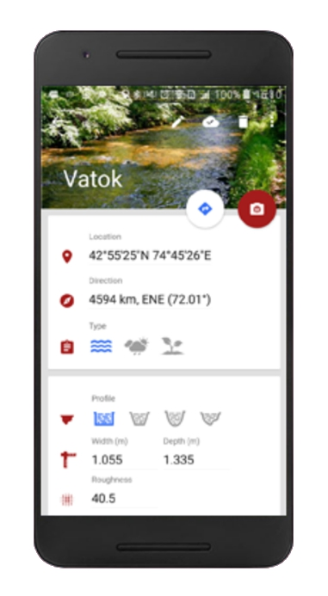

Content*s*

What does the discharge app do? 3

Getting started 4

Smartphone requirements 4

Download 4

Creating an account 4

Menus 5

How to measure on an existing site? 6

Recording 6

Processing 6

Choosing a location for a discharge site 11

Creating a new site 12

Cross section and marker conventions 13

Placing markers 13

Color and Material for Markers: 14

Measure inter marker distances and positions 14

Examine Data 15

Pending measurements 16

Settings MENU 16

Settings 16

Help 16

Feedback 16

Web platform discharge.ch 17

Sign in 17

Managing organizations and users 17

Organization 17

Users 18

Managing sites 19

Map 19

Site infos 19

Site measurements 19

Rating curves 19

# What does the discharge app do?

The Discharge app is a non-intrusive, optical flow measurement tool, suited for natural water streams, irrigation furrows and water channels. The app is fully integrated in the web platform ‘discharge.ch’. At dedicated measurement sites the app can accurately determine water level and discharge. The discharge is calculated either via rating curve, or via surface velocity that is measured by the app. All calculations are performed directly on the smartphone, such that the app can operate in offline mode. An operational site requires 4 reference markers and a known cross sectional profile.

The Discharge web platform discharge.ch is designed for large scale acquisition of hydrometric and meteorological data. The user can navigate through measurements, graphs and proof images. Site properties can be edited either via app or web platform and updates are pushed immediately to all registered devices. Sites may be grouped into organizations. State of the art tools and intuitive usability facilitate administrational aspects user and organization management.

# Getting started

## Smartphone requirements

The application Discharge is available on Android devices with the following requirements:

* Android 4.1 or higher
* Smartphone Camera: 25 fps video
* ARM processor

Tested devices:

* SAMSUNG GALAXY S4
* SAMSUNG GALAXY S5
* SAMSUNG GALAXY S7 edge
* SONY Xperia Z1 compact
* TECHNO W3, OPPO Neo 7
* LG G3
* HTC 10

## Download

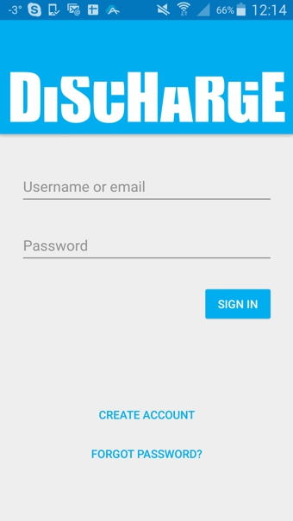Discharge is available on Google Play Store. Search for “Discharge river” and download the application (<https://play.google.com/store/apps/details?id=ch.photrack.discharge&hl=en>).

## Creating an account

Upon opening the application on your Android device, the application will ask for your sign in information. New users may simply click ’create account’, which will trigger the registration process. The password has to be at least 6 characters long. Please make sure to enter a valid email address in case the password needs to be reset.

# Menus

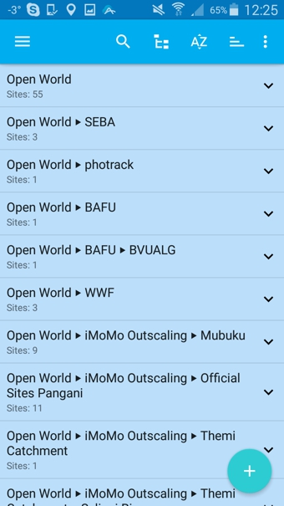After the login the Discharge shows all sites in all organizations to which the user has at least viewing permissions.

The organizations can be expanded and collapsed; the sites within organizations can be sorted alphabetically or by distance to the user location. Sites may also be searched for directly.

Each time the app is started, the app is synced with the cloud. **IMPORTANT NOTE**: To **force synchronization with the cloud**, the screen can be ‘pulled’ downwards. A spinner appears, indicating that the synchronization process is ongoing.

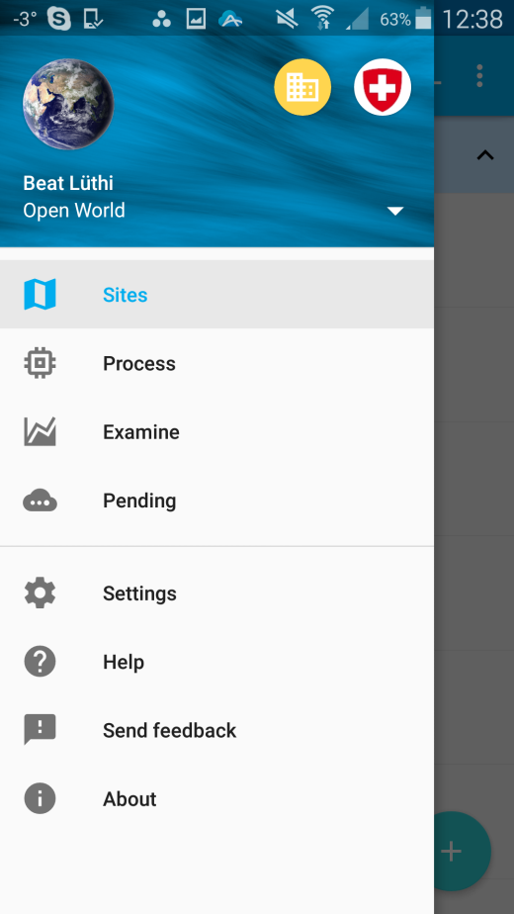With a swipe from the left or by clicking the menu icon on the top left the menu appears. The top section is showing in which organization context the user is and it lets the user switch between available organizations.

The menu items allow navigation through the app functionalities. The main item is ‘Sites’, from which a particular site can be chosen to edit it, find it, or to take a measurement.

# How to measure on an existing site?

## Recording

By clicking on any particular site a view opens that contains site specific information and properties, all of which may be edited if the user has respective permissions.

Assuming a site is setup and ready for usage there are two ways to make a measurement via the two icons ‘collect’ and ‘camera’.

The first way will open a view ‘collect discharge data’. The user can type in a metric gauge reading and submit it to the cloud by pressing the cloud icon at the bottom of the view.

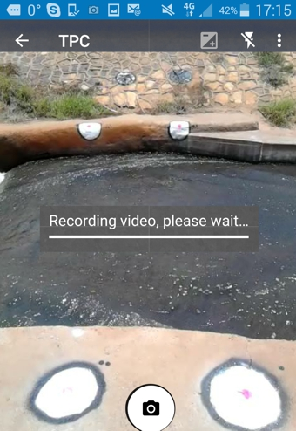

## Processing

For the measurement, the user must click the camera button on the top right of the screen. This starts the camera preview and the user should hold the device such that the four reference markers are all visible and placed inside the four quadrants of the view.

When the user is satisfied with the view, he presses the camera icon at the bottom of the screen. This will trigger the actual recording that takes about 5 sec. During this time the device needs to be held as steady as possible.

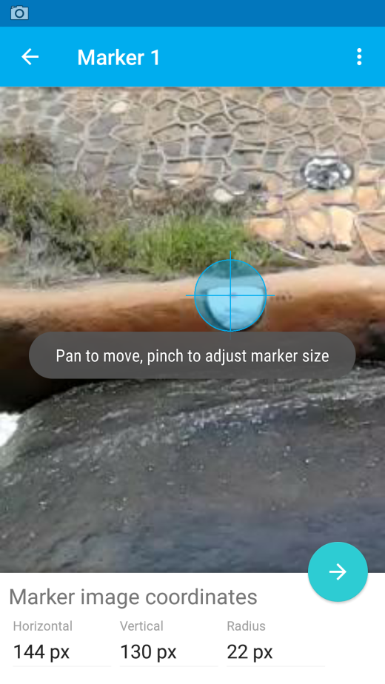After the video is recorded, the app shows the screen which asks the user to select the location of the markers. For each marker the user needs to move the blue hair cross exactly over the site marker. For now, the ‘adjust marker size’ feature can be ignored (later version will use this feature for automatic marker detection).

**IMPORTANT NOTE**: If the user wants to postpone the processing, the app or phone may just be switched off, or another recording may be taken. The user can enter processing at any point in time later, via the main menu ‘Process’.

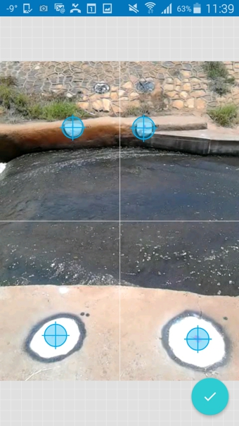

After positioning the four markers, a last control view appears and by pressing the checkmark the app will calibrate the view, i.e. it will determine the device position and orientation relative to the site. This will take only an instant and then the menu will move on to the level picking step.

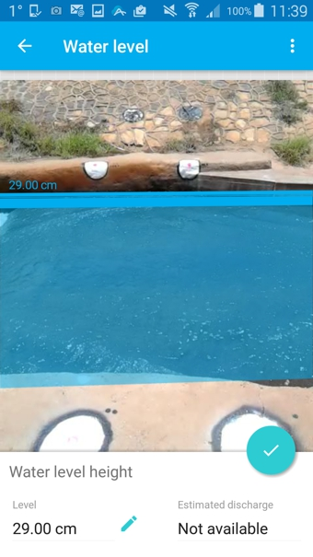The water level is picked by moving the blue line to the actual water level. Pinching will zoom into the image, making it easier to click the water level accurately. As the user slides the water level up and down, in the lower part of the image the water level in metric units is shown.

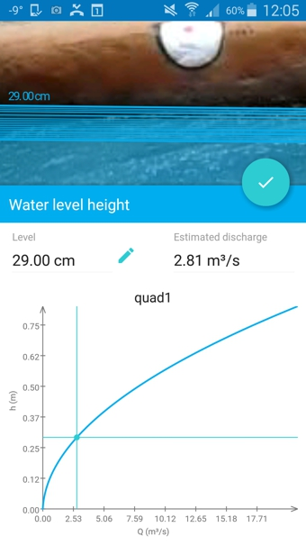If the site has a rating curve, the calculated discharge will be shown and adapted directly on the displayed rating curve.

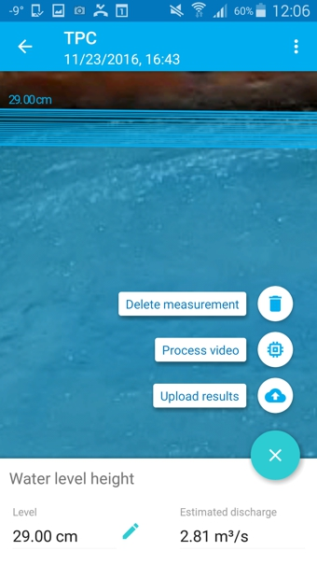After tapping on check mark, the user has a choice to make. The measurement can be deleted, processed for velocity and discharge, or, if a rating curve is available, the result can be uploaded to the cloud directly, without processing the video for surface velocity.

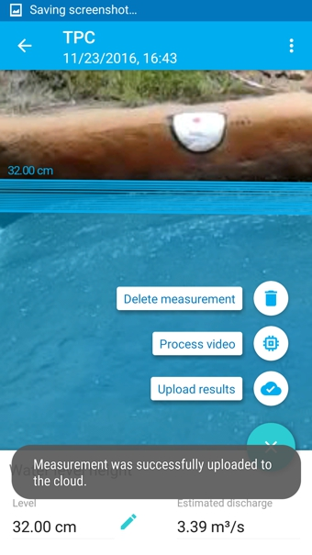After pressing ‘upload results’ the app will successively report that the measurements has been ‘saved’, ‘sent to the cloud’, and finally, ‘successfully uploaded to the cloud’. If successful, the app is receiving a confirmation from the server. Should the upload experience some problem, the measurement will be stored with the pending cases. Those cases can be treated from the menu ‘pending’.

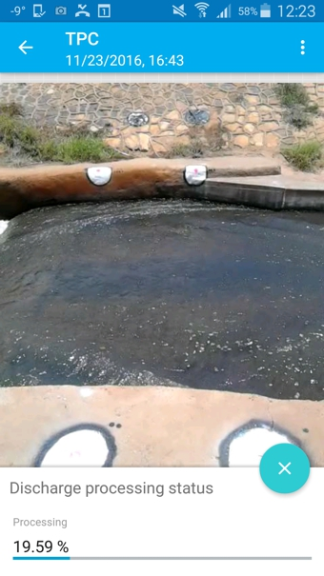If the button ‘process video’ is pressed, the app will start calculating the velocity, and successively, the discharge.

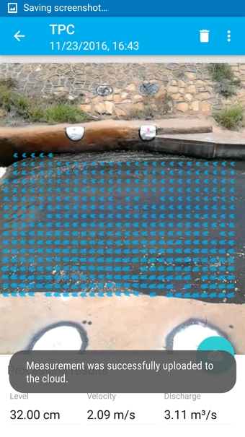After the processing is done, the velocity vectors are rendered, as well as the calculated discharge, velocity and water height. By clicking the cloud button, the measurement is sent to the web-platform.

# Choosing a location for a discharge site

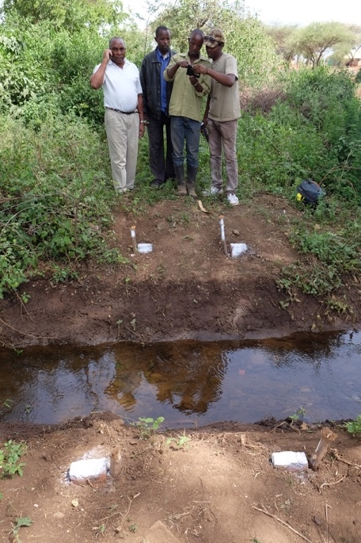The identification of a convenient measurement site along a given river, channel or furrow is of major importance as it determines the measurement accuracy and a smooth setting-up and calibration procedure. To select a channel/river section, please check the following prerequisites:

* The cross sectional profile of the stream is constant and well defined (**IMPORTANT NOTE**: Please be aware that for now the app is supporting only regular channel/river cross sectional profiles, such as rectangular, trapezoidal, and parabolic. So called ‘free’ cross sectional profiles can be entered only through the web platform, which may require support by the Discharge team)
* At least one side of the river section is easily accessible
* There are enough visible structures on the moving water surface, like turbulent patches, waves, leaves, bubbles, etc.

If these prerequisites are fulfilled, continue by looking through the smartphone camera(in portrait mode!)while standing on one side shore of your candidate channel/river section and move around to find an optimal measurement position that fulfills the following requirements:

* Both shores are visible
* The waterline on the opposite side can be seen at an angel that is between ~20-70 degrees (measured from the horizontal)
* It is possible to create/place 4 artificial markers (2 on each shore), which are clearly visible through the phone camera (using spray, paint, concrete etc.)
* The four markers should be approximately in a horizontal plane (**IMPORTANT NOTE**: it is possible to have more general marker positions, but such positions have to be entered through the web platform, which may require support by the Discharge team).
* The markers are visible for all flow situations of interest (e.g.: high-flow, low-flow, flood)

The measurement position is not too far away from the channel/river, i.e. the water surface should expand over at least 1/3 of the image height.

# Creating a new site

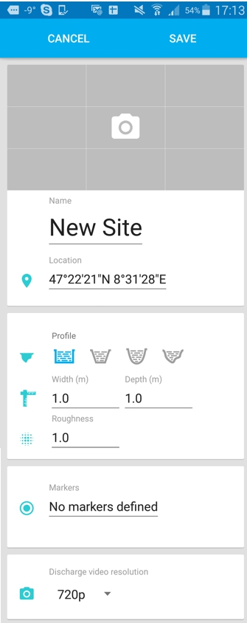From the sites menu a new site can be added by pressing the + button at the bottom right of the screen. All properties initially have some default values, which may be edited now or later. At any time the changes may be ‘saved’ or ‘canceled’. After ‘SAVE’ the local changes can be pushed to the cloud by pressing the icon with the cloud and the upward arrow. A checkmark inside the cloud indicates that the device is synced with the cloud.

**IMPORTANT NOTE**: The user may at any time proceed editing the site properties by using the web platform.

A site can have a site image, which may be taken by the device camera, or which may be chosen from existing images stored on the device.

Obviously a site should have a name and a site has a location. Both properties can be edited from the app or from the web platform. If the location service is witched on, by default the GPS position is already filled in and does not require editing.

The site can have standard cross sections or ‘free’ cross sectional profiles (**IMPORTANT NOTE**: Please be aware that for now the app is supporting only regular cross sectional profiles, such as rectangular, trapezoidal, and parabolic. So called ‘free’ cross sectional profiles can be entered only through the web platform, which may require support by the Discharge team). Choose the profile type and fill in its ‘width’ and ‘depth’. Please note that the depth refers to the distance between the channel banks and the bottom of the channel and NOT the depth of water.

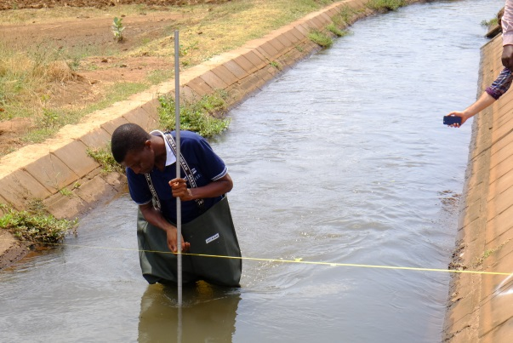The roughness value, kst for Strickler value) is important. Very smooth surfaces have high values kst~50-100 and very rough surfaces typically range from kst~25-50. More information is given on the web platform; on each site info panel, next to the roughness field, clicking the information icon ‘I’, will pop up a table with roughness values.

Touching the field ‘No markers define’ will open the marker menu, which allows to enter simple measurements of the marker inter-distances, as well as their distances relative to the cross section. It is explained in more detail below.

Finally, we have the card ‘Discharge video resolution’. It defines the pixel resolution at which the app will attempt to record its videos for the measurements. A good default value is 1080p. More experienced users may try to reduce resolution to 480p. Processing will be much faster, and if the signal is strong enough, the accuracy for the velocity measurement will not suffer.

## Cross section and marker conventions

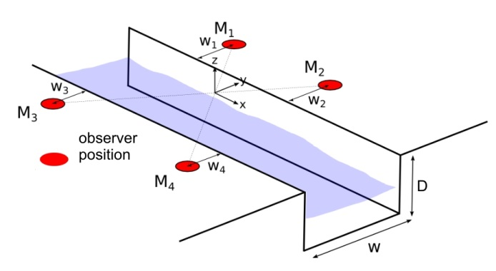All sites need to have 4 markers (M1-M4) and the Discharge convention is that they are placed like shown in the schematic drawing. The four markers should be approximately in a plane that is parallel to the water surface (**IMPORTANT NOTE**: it is possible to have more general marker positions, but such positions have to be entered through the web platform, which may require support by the Discharge team).

## Placing markers

The markers must be inside of the camera view and clearly visible by the smart-phone camera at the chosen resolution. To find a good place for the markers, the camera preview screen of the app can be used. This screen is accessed by clicking on the camera icon of the site view. Ideally one person is looking through the camera preview screen while guiding a second person to where the markers should be placed.

The requirements for a correct marker setting are:

* 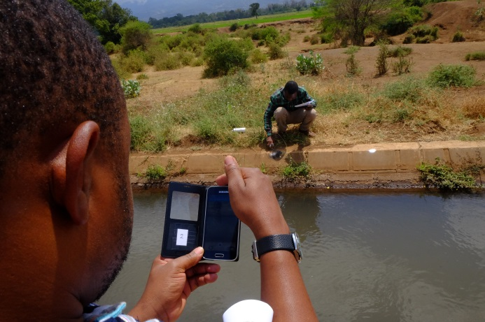The markers should be located in such a way that they are visible on the screen of the smartphone. Ideally, they should be on the outer corners of your view window but still visible after small movements of the camera.
* Make sure the markers do not move.
* The markers should be permanent and distinguishable from the surroundings in different light conditions (sun/clouds).
* Make sure the highest possible water level does not flood the markers.

**IMPORTANT NOTE**: Involve communities and stakeholders to make sure they know the purpose of these markers.

## Color and Material for Markers:

Very often it is a good solution to spray or paint the markers onto the wall or rocks of the channel/furrow. If there is only earth the markers can be buried rocks, (cemented) poles. Alternatively, if trees are next to the channel/furrow, iron sheets can be mounted (nailed) onto the tree trunks. For colors a good choice is some dark (black) background and some bright (white) clear feature, like a cross or a circle. The diameter of the features can range from 5cm (if markers are at small distances of 2m from the smartphone) to 50cm for distances up to 20m.

## Measure inter marker distances and positions

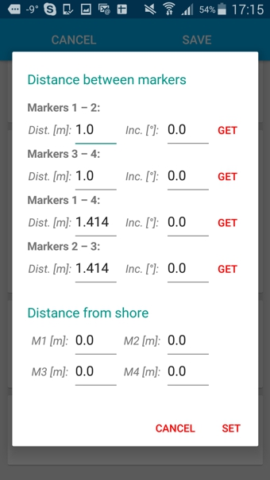Once the markers have been placed, they need to be measured in. For the standard cross sections ‘rectangular’, ‘trapezoidal’, and ‘parabolic’ the measurements can be entered directly via app (**IMPORTANT NOTE**: we repeat also here that it is possible to have more general marker positions, but such positions have to be entered through the web platform, which may require support by the Discharge team).

The ‘measuring in’ involves measuring four distances *between* the markers and 4 distances of the markers *relative* to the cross sectional profile. Please read, understand and follow the conventions described above before following these simple steps guidelines:

* The length unit is meter
* Measure the distances between the markers on each shore, 1-2, 3-4.
* Measure the diagonals between the markers 1-4 and 2-3.
* Ignore the inclination fields!
* In the fields M1,2,3,4 please fill in the respective distances from the markers to the channel, as indicated in the above sketch. Note that all values need to be positive.

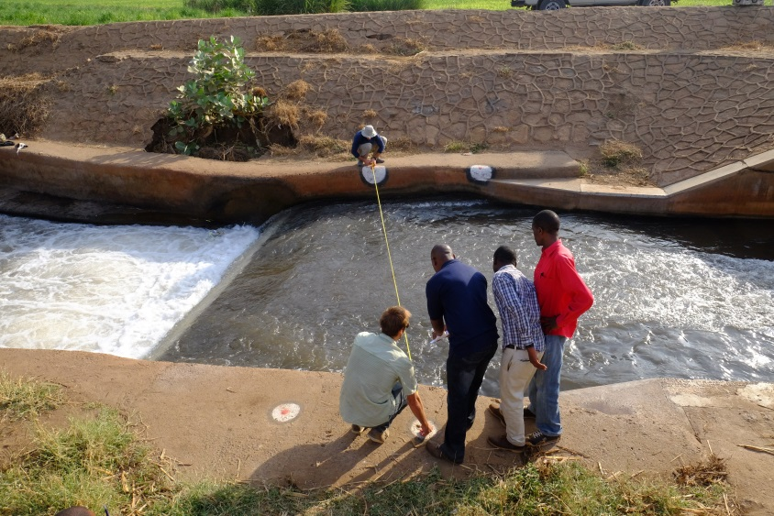**IMPORTANT NOTE**: Save the site after you press ‘SET’ and publish the site by pressing the icon with the cloud and the upwards arrow.

# Examine Data

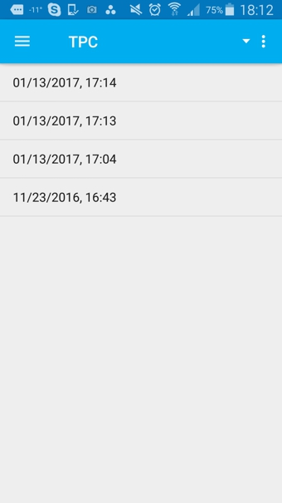A user may wish to examine the results of a processed video. From the examine screen measurements can be chosen by their time stamp. Clicking on a time stamp will open a screen showing the status of the selected measurement. If it has not yet been processed the user can click the ‘process’ icon and continue. If the measurement however is processed a proof image is opens. The proof image is showing the determined velocity field and the obtained values for water level, velocity and discharge.

If everything is looking fine, there is obviously no need for action. If something looks wrong there are several options.

If the organization of the site is run in a mode that validates measurements, the user has the option to edit (reprocess, delete) the measurement until the measurement has been validated by an organization manager, i.e. by a user with the permission to validate measurements. The validation process is done on the Discharge web platform.

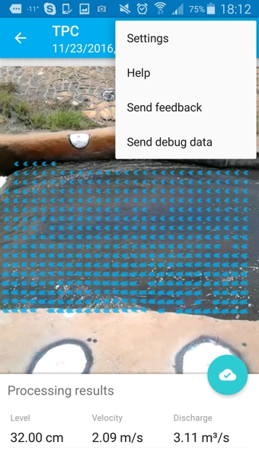In any case, if something looks wrong, or more generally if the user has question about the measurement that requires back stopping services of the Discharge team, an option exists to transmit the complete measurement (recorded movie and all relevant parameters) to the Discharge server. This is done via settings, by clicking the button ‘Send debug data’.

# Pending measurements

This menu gives an intuitive oversight over remaining actions for individual measurements. The user is informed if either the upload of result values or proof images are still pending.

# Settings MENU

## Settings

Under settings, a user can modify the way data is transmitted to the Discharge server, i.e. ‘to the cloud’. By default data may always be transmitted if the device is connected to a Wi-Fi network. In addition the app may communicate with the cloud over mobile data connection (set as default) or at least the measurement values may be transmitted to the cloud via SMS connection (provided that the site organization is operating in a suitable plan).

## Help

Clicking help is directing the user to a pdf download for this user manual.

## Feedback

Through the ‘Send feedback’ function, users can communicate directly with a person from the Discharge team. A menu will open which allows sending text messages as well as supporting images, e.g. screen shots. The Discharge team will respond and deal with any issues as fast as possible.

# Web platform discharge.ch

The Dischargeweb platform is the natural counterpart of the Discharge app, it completes the Discharge system. Its purpose is to manage organizations and the sites and users that are associated with the organizations. While some operations can be performed conveniently from either the app or from the web platform, typically the web platform offers more functionality.

The web platform is designed for intuitive usage. The purpose of this section is to elaborate some underlying principles and to point out some convenient features that can only be controlled through the web platform.

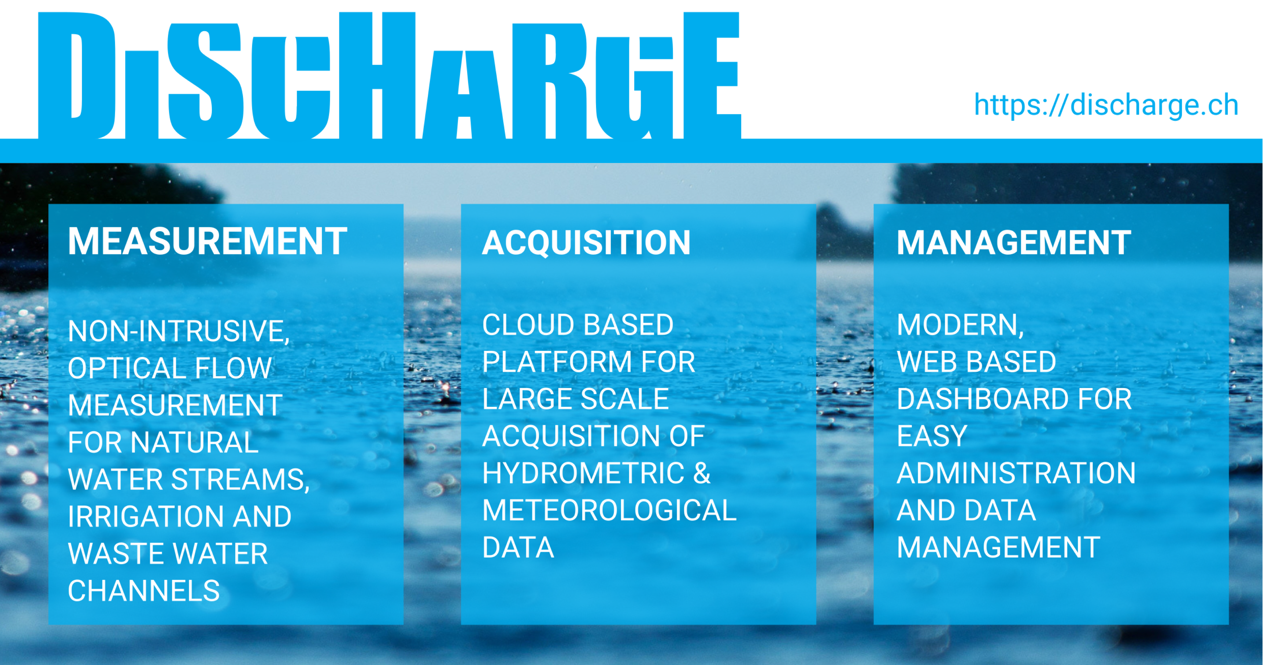

## Sign in

For the sign-in exactly the same account credentials are valid as for the mobile app. Vice versa; an account can be created on the web platform and is valid for the mobile app.

## Managing organizations and users

### Organization

It is important to realize that organizations are pivotal to the Discharge system; they comprise the backbone of the Discharge structure. Discharge organizations give home to Discharge sites and to Discharge users. Organizations can have any level of sub-organizations. Like in any other organization, also in Discharge organizations users play different roles. Some manage, some work. More particular, in Discharge a user can view, manage, create and export stuff. The user roles, and thus the structuring of any organization, are defined through a small set of permissions. Note that a user generally has different permissions for different organizations. Finally, also the different payment plans are referenced to the root of each organization structure, i.e. to the organization that does not have a parent.

Upon login, the user is in the context of the organization he was in before login out the last time. A first time user will be casted into the organization ‘Open world’. At the top left of the screen the current organization is indicated and it may be changed by clicking onto the ‘organization switcher’. The listed items show all organizations the user belongs to.

The creation of a new organization is facilitated through a wizard. The starting point is the + icon on the top right of the screen. After being clicked the + expands into two icons either for a new ‘site’, or for a new ‘organization’. The important thing to realize is that the new organizations can either become a root organization, i.e. without a parent, or it can become a sub-organization of the currently selected organization.

### Users

Users are members of one or several organizations. A user can take measurements at all sites of the organizations he is member of. The only way to become a member of an organization is ‘by invitation’, i.e., an existing member with the permission to ‘manage users’ (a user manager) can invite, well actually ‘add’ new members, the invitation cannot be declined. Adding a user to an organization is done via the +person icon (the top right of the user card). By default, the new user cannot do much besides ‘create measurements’. He has to work. The user manager can edit these permissions at will at any time – including later. For example if you want somebody to help you with management tasks, you need to make sure you give this new user the necessary permissions. To modify permissions later the manager needs to hoover over the user field, and ‘lock’ icon appears. Clicking the ‘lock’ icon will open again the permission menu. Clicking the entire user field will open a card where various user properties can be edited; photo, name, etc. Finally there is a – icon, which allows removing a user from the current organization.

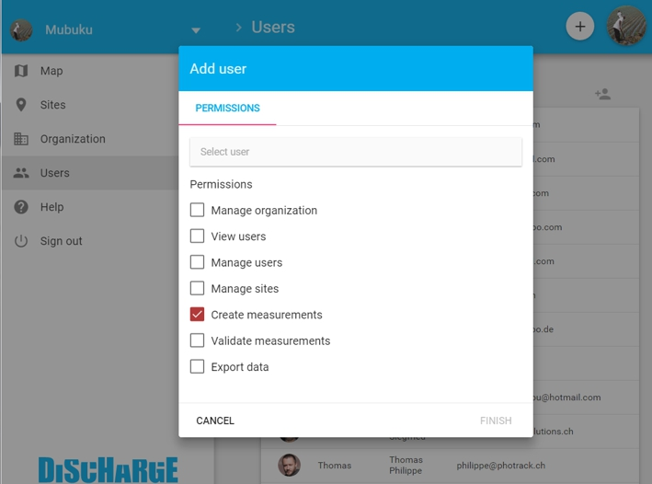

## Managing sites

### Map

The map view is the default starting view and the platform remembers the organization the user was switched into before the last logout. The map is showing balloons which indicate site locations. Hoovering over them causes a popup screen to appear. It shows the measurements of the last 7 days. Clicking a balloon opens a site card that contains site information and measurement results.

At the bottom left of the view, next to the +/- zoom buttons there is a settings icon. The settings allow e.g. to toggle if the map shows all sites of the current organization only, or if it shows in addition also all sites from its sub-organizations.

### Site infos

The site card has three tabs (info, measurements, rating curve) and opens showing the tab ‘info’, which contains all the site properties. If the user has the permission to ‘manage sites’, a pencil is shown that allows to enter the editing mode. In the editing mode all properties can be clicked and modified in an intuitive way.

**IMPORTANT NOTE**: It is here where the necessary entries for ‘free’ cross sectional profiles can be edited. This is not yet part of the current app release and may likely require special support by the Discharge team.

### Site measurements

Everything regarding the measurements data (viewing and exporting) is designed auto-intuitive and is not discussed further here.

### Rating curves

When there exist already a number of measurements for different water levels, it is possible to fit a rating curve (discharge – water height relation) to the data. To do so click the + icon below the chart.

Fitting of rating curves can be done manually by adjusting the parameters of the curve type (automatic fitting is planned for a future release).

**IMPORTANT NOTE**: The primary rating curve is synced to the app. This means that with a defined rating curve the app can be used to ‘only’ measure the water level and determine the discharge via the rating curve. This feature is particularly useful for situations with low water levels where the measuring of the surface velocity can become problematic.